December 11, 2025
Subject: Help us build colorectal surgery capacity in Ghana

Dear Colleagues and Friends,
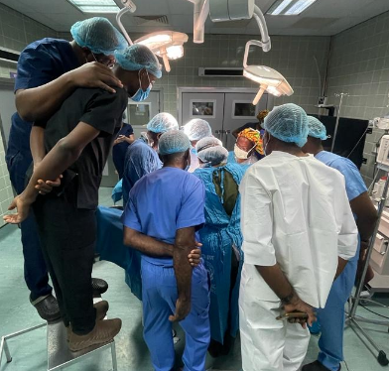
I hope you’re doing well. If it’s been a while since we last connected, I hope things have been going smoothly on your end. As the holiday season approaches, I wanted to share something personal and ask for your generosity if you’re able.
In 2023, I helped create Ghana’s first colorectal surgery fellowship to address a stark reality: in a country of over 33 million people, not a single trained colorectal surgeon existed, even as colorectal cancer and related conditions continue to rise across sub-Saharan Africa.
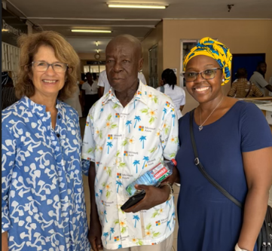
Just a few months after the program started, my uncle—who lives in a remote village and whom I hadn’t seen in nearly 20 years—developed an obstructing colorectal cancer. He was transferred from hospital to hospital because no specialist was available. By pure grace, he eventually arrived at the one site where our new fellowship was underway. There, he received lifesaving surgery—and I received the unexpected gift of reconnecting with him again. I have always done this work for impact, but I never imagined the program would save someone in my own family—so soon after we launched it.
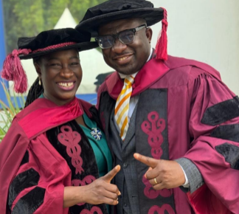
Since then, we’ve graduated two fellows, a third is close to finishing, and we are expanding the program because the need is immense and the momentum is real. (Photos: Left—my uncle at his postoperative visit; Top right—me teaching trainees and practicing surgeons in Ghana; Bottom right—our first two graduates, Dr. Ijeoma Aja (2025) and Dr. Kwabena Agbedinu (2024).)
If you’re considering end-of-year giving, I would be grateful if you’d support the Global Colorectal Surgery Education Initiative, our 501(c)(3) dedicated to training the surgeons who have dedicated their lives to taking care of patients in a very limited resource setting. Every gift—large or small—directly strengthens this effort.
Donate here: www.globalcolorectalinitiative.com/donate or at the QR link below
EIN: 93-3335297

Mi dase (thank you!)
Gifty

